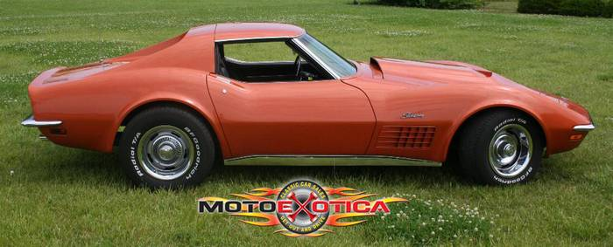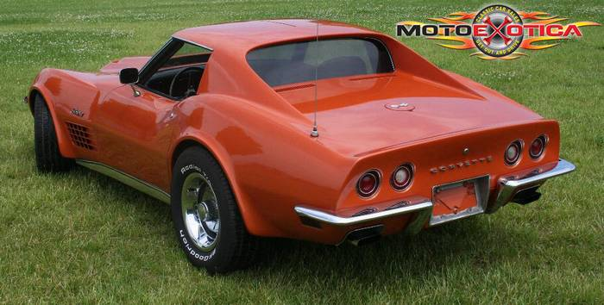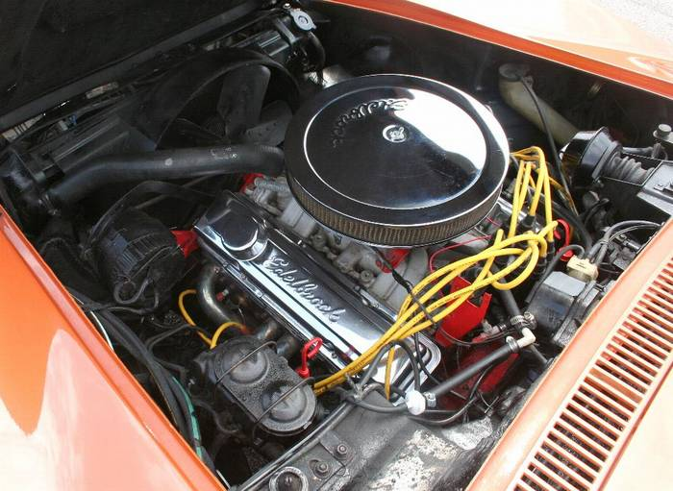

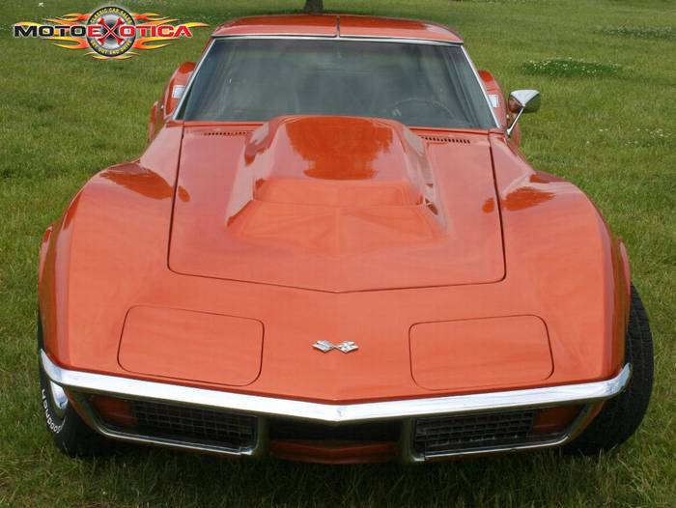

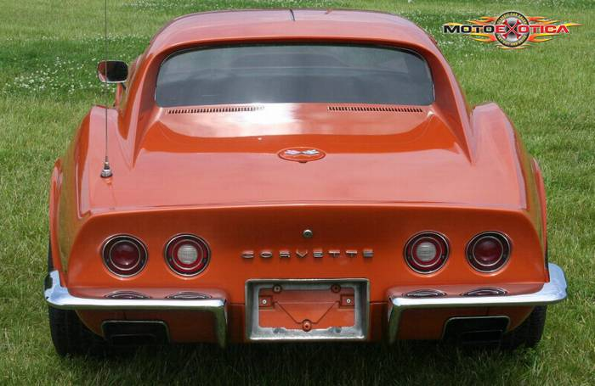

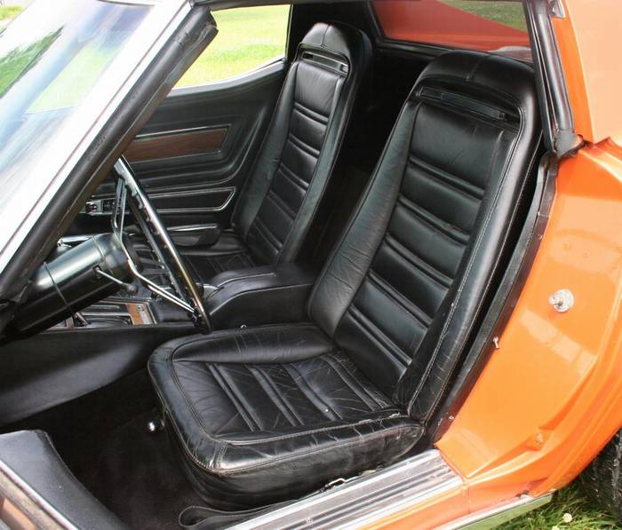

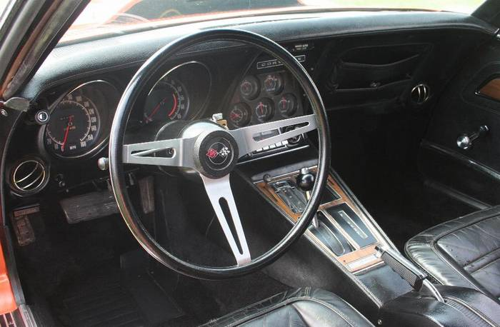

MotoeXotica is offering another beautiful 1972 Chevy Corvette. The car is finished in a beautiful orange with T-Tops and a big block hood which looks great. We do believe that this is the original 350 V8 motor for the car. The casting number on the block is CKX and it does have the car's VIN stamped on it.
VIN number is 1Z37K2S515195 and the current mileage shows 81,108 and is believed to be actual. The car is being sold on a mileage exempt MISSOURI title. This is another fantastic Corvette that you can buy just in time for the spring time cruises and rallies. Bid to own a piece of Corvette history that was built right here in St. Louis Missouri. GET OUT AND DRIVE!
The paint is in great condition and has no major dings, scratches or nicks. The fiberglass body looks very good with no spots where there is major cracking or damage. This includes the big block hood. The front and rear bumpers are both in great condition with no damage. The paint on the car is newer but we have no documentation as to when the car was repainted. We believe it has been sometime in the past few years.
The black interior is in good overall condition and appears to be all orignal. The seats do show some minor cracks and splits but none are major. Just normal wear and tear. The dash is in good overall condition with no major splits or tears. All gauges appear to be in good working order as well as the lights, blinkers and horn. The original radio is still in the car and works fine as well as the wipers and wiper door which is vacuum operated. The carpet is in very good condition with no major staining or tears.
The motor is a 350 Cu In V8 that has a CKX casting number. The engine and engine compartment are both clean in very original condition. There has been a 4bbl Demon carb installed as well as an Edelbrock intake and stainless headers. The exhaust note sounds great. This is a power steering and power brake car. The automatic transmission performs fine and shows no problems. The Rally wheels are all in very good condition with BF Goodrich Radial TA radials all around.
Legal Information And Disclaimer
TO BID YOU MUST BE OVER 18 and pay with a money order, cashiers check or wire transfer. Please do not bid without the intent to finalize this transaction. Winning bidders that do not finalize will receive negative feedback. Sorry, NO bid retractions allowed in the last 24 hours of the auction, ask questions BEFORE you bid.
IF YOU SHOULD GET HERE AND NOT LIKE THE CAR FOR WHATEVER REASON, I WILL PROMPTLY REFUND YOUR MONEY WITH NO QUESTIONS ASKED.
Documentation Fee: There will be a $195.00 fee added to each car sold in the United States. This includes title transfer, inventory tax, holding costs, vehicle preparation, storage and overnight documentation delivery.
ALL SALES ARE FINAL WITH CAR BEING SOLD WHERE IS, AS IS. ! ...Please, ASK if you have a question! Seller reserves the right to end auction early. Cell phone provided below and all Email will be answered PROMPTLY.
Transportation:
• For an open carrier transportation quote call Dave Meeker Auto Transport toll free at 1-800-936-5442 They can also be found online at www.davemeekerauto.com
• Buyer will pay for any and all transportation costs. I will assist you in arranging for transportation, but you will be responsible for contact and payment directly with shipper. Prices will vary so check around if this is an issue. Shipping can take up to 14 + days due to scheduling.
International Transportation
We are happy to accommodate our overseas buyers! Over the last year we have exported cars to Norway, Germany, Estonia, Puerto Rico, Hawaii, Alaska, Costa Rica, Brazil, British Columbia, Canada and other locations!
Terms of Auction & Sale:
• The vehicle is offered with a right to a personal inspection by any bidder or agent of any bidder. The Vehicle is being sold by a Licensed State of Missouri Dealer (SRS Enterprises, Inc.).
• Any Missouri resident must pay local MO sales tax and licensing fees. All other will do so in their home state.
• The vehicle is available for inspection prior to bidding. If you are the high bidder and unable to inspect said vehicle before auction close, you or an agent will have (10) days to inspect said vehicle after the close of auction. I encourage a physical inspection strongly to avoid any misunderstandings or representations.
• Bidders with less than 10 feedbacks MUST email us before bidding showing their intent to purchase the vehicle. Due to increasing non-paying bidders, we reserve the right to cancel your bid if you do not have more then 10 feedbacks. Sorry. WE WILL NOT TOLERATE BID INTERFERENCE!
• All disputes arising out of or resulting from this sale shall be finally determined by binding arbitration in St. Louis, Missouri in accordance with the commercial rules of arbitration of the American Arbitration Association. The arbitration shall be carried out by one or more arbitrators in accordance with said rules. Any award shall be enforceable in any court of competent jurisdiction in the same manner as judgments. This agreement to arbitrate shall survive the sale of the automobile described herein. Buyer and Seller hereby agree that Missouri law shall control for all purposes under this Bill of Sale. Buyer and Seller hereby consent to the personal jurisdiction of the state and federal courts of Missouri to specifically enforce the agreement to arbitrate and to enter judgment of and enforce the award of the arbitrator.
Payment Terms :
Payment must be made by Cashiers Check, Money Orders or Wire Transfers payable in US Dollars.
• A Refundable deposit in the amount of $500.00 must be received within Twenty-Four(24)hours of the auctions close either by Master Card, Visa or PayPal. The buyer has ten (10) days from close of auction to inspect the vehicle. If the vehicle is not to your liking within this ten day inspection period then your deposit will be refunded 100%. If an inspection or decision takes longer then ten days and you find the vehicle not to your liking, your deposit will be forfeited and the car will be relisted.
• Final payment must be received within ten (10) days of the auction close. The refundable deposit only applies if you or an agent inspect said vehicle in St. Louis and find it not to your liking. I will not be responsible for buyers remorse or problems found to said vehicle once they have left my property. I am just being realistic, most of the cars I deal in are vintage and by their very nature will need TLC and some degree of attention sooner or latter. These are not new cars and should not be treated as such.
• Once full payment has been received, Seller will fax a copy of clear title, Bill of sale, Buyers guide and additional DMV forms to the Buyer to sign and return via fax. The forms must be returned to the Seller prior to the shipment of said vehicle. Original paperwork will be sent to Buyer Via overnight mail seven(7)days from date of final payment. Transportation will commence only after final payment and signed documentation are received. Once a car is picked up from our premises, you will NOT be able to return the car.
• All above terms and conditions are applied to vehicle sales, whether through Ebay or otherwise.
• Sorry, but in all fairness to the bidding process, I will NOT disclose my reserve price until the auction has ended.

MotoExotica IS An Authorized Exclusive Missouri Dealership which specializes in Exceptional Classic Cars, Project Cars, Exotic and High Line Vehicles!

Get In Touch with Jim Flacke, General Sales Manager
• Email [motoexotica@aol.com] | • Toll Free[1-866-543-9393] | • Local[636-600-4600] | • Fax [636-600-4062]
• After Hours [314-703-5167]

